QUESTION 1

CODE

#include<stdio.h>

int main(){

printf("k230800 Muhammad Mufeez \n\n");

int i,j,batsman,innings,total,highscore,average,centuries,half_centuries;

printf("Enter no of batsman: "); //input for the no of batsman

scanf("%d",&batsman);

printf("Enter no of innings: "); // no of innings

scanf("%d",&innings);

int arr[batsman][innings];

//runs scored by each batsman in an inning

for(i =0; i<batsman;i++){

for(j = 0 ; j < innings;j++){

printf("Enter runs for batsman %d in inning %d: ",(i+1),(j+1));

scanf("%d",&arr[i][j]);

}

}

for(i =0; i< batsman;i++){

printf("\n\nFor batsmen %d: ",(i+1));

total=0;

highscore=0;

centuries=0;

half_centuries=0;

for(j = 0 ; j < innings;j++){

total += arr[i][j];

if(arr[i][j]>highscore){

highscore=arr[i][j];

}

if(arr[i][j]>49 && arr[i][j]<100){

half_centuries++;

}

else if(arr[i][j]>=100)

centuries++;

}

average = (total/innings);

printf("\nTotal runs scored: %d",total);

printf("\nAverage runs: %d",average);

printf("\nHighscore: %d",highscore);

printf("\nNo of centuries: %d",centuries);

printf("\nNo of half-centuries: %d",half_centuries);

}

return 0;

}

OUTPUT

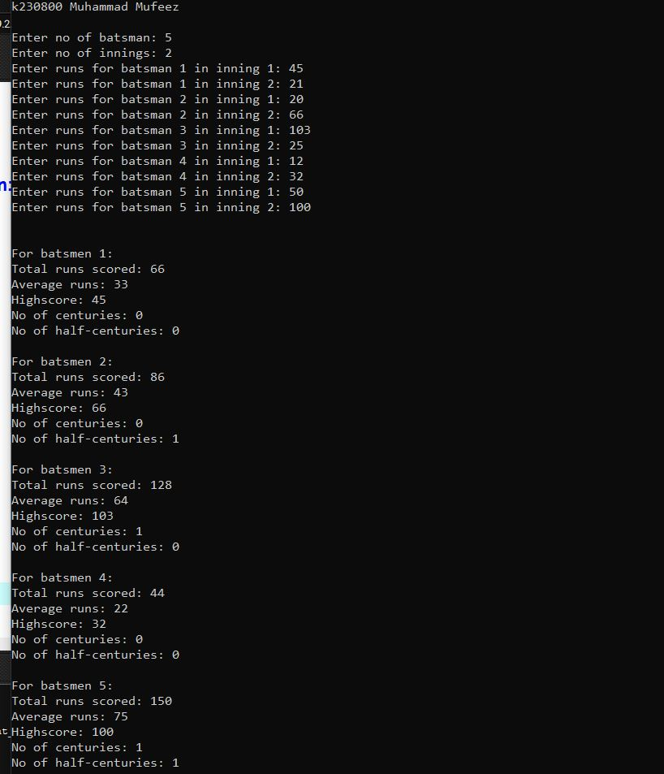

QUESTION 2

CODE

#include<stdio.h>

int main(){

printf("k230800 Muhammad Mufeez \n\n");

//incomplete

int m,n;

int cols=0,rows=0,ri=0,ci=0,i,j;

int arr1[100][100];

int arr[100][100];

printf("\nEnter number of rows and columns with a space between: ");

scanf("%d %d",&m,&n);

for(i=0;i<m;i++){

printf("\nRow %d",(i+1));

for(j=0;j<n;j++){

scanf(" %d",&arr[i][j]);

}

}

for (i=0; i<m; i++)

arr1[i][0] = arr[i][0];

for (j=0; j<n; j++)

arr1[0][j] = arr[0][j];

for (i=1; i<m; i++) {

for (j=1; j<n; j++) {

if (arr[i][j] == 1){

int min = arr1[i][j - 1];

if(arr1[i-1][j]<min)

min= arr1[i-1][j];

if(arr1[i-1][j-1]<min)

min = arr1[i-1][j-1];

arr[i][j] = min + 1;

}

else

arr1[i][j] = 0;

}

}

return 0;

}

OUTPUT

QUESTION 3

CODE

#include<stdio.h>

int main(){

printf("k230800 Muhammad Mufeez \n\n");

int day,l_price,i,pref_day,count=0;

char ch,time;

char days[5][30]={{"monday"},{"tuesday"},{"wednesday"},{"thursday"},{"friday"}}; // weekdays array

//array hardcode

int flights[5][4]= {

{1,300,0,59999952},

{1,320,1,310},

{0,599999245,1,280},

{1,380,0,5897545},

{1,375,1,400}

};

//to get input of the array from the user

// int flights[5][4];

// for(i=0;i<5;i++){

// printf("Enter for %s: ",days[i]);

// for(int j=0;j<4;j++){

// scanf("%d",&flights[i][j]);

// }

// }

//assigning garbage value on price column having no available seats

for(i=0;i<5;i++){

for(int j=0;j<4;j+=2){

if(flights[i][j]==0)

flights[i][j+1]=59992653;

}

}

printf("\nEnter 't' for preference wrt time, 'd' for days: ");

fflush(stdin);

scanf("%c",&ch);

switch(ch)

{

case 't':

{

printf("\nEnter 'm' and for morning 'e' for evening: ");

fflush(stdin);

scanf(" %c",&time);

switch(time)

{

case 'm':

{

day = 4;

l_price= flights[4][1];

for(i=0;i<5;i++){

if(flights[i][0]==1){

if(flights[i][1]<l_price){

day=i;

l_price=flights[i][1];

}

}

}

printf("\nFlight is available on %s, price = %d",days[day],l_price);

break;

}

case 'e':

{

day = 0;

l_price= flights[0][3];

for(i=0;i<5;i++){

if(flights[i][2]==1){

if(flights[i][3]<l_price){

day=i;

l_price=flights[i][3];

}

}

}

printf("Flight is available on %s, price = %d",days[day],l_price);

break;

}

default:{

printf("Error!! please enter from the given value..! Restart the program..");

break;

}

}

break;

}

case 'd':

{

printf("Enter no of day, (week starts from monday)i.e. 1 for monday: ");

scanf("%d",&pref_day);

count = pref_day-1;

if(flights[count][0]==1 || flights[count][2]==1){

if(flights[pref_day-1][0]==1)

printf("\n\nFlight available in Morning with Price on %s: %d",days[count],flights[pref_day-1][1]);

if(flights[pref_day-1][2]==1)

printf("\n\nFlight available in Evening with Price on %s: %d",days[count],flights[pref_day-1][3]);

}

else{

printf("\n No flights available on the given day");

}

break;

}

default:{

printf("Error!! please enter from the given value..! Restart the program..");

break;

}

}

return 0;

}

OUTPUT

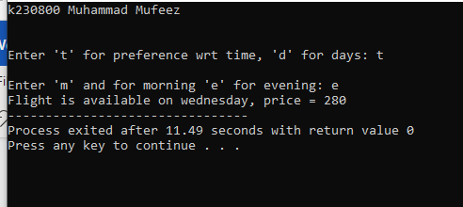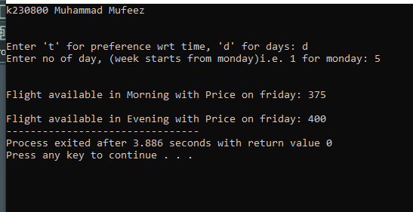

QUESTION 4

CODE

#include<stdio.h>

int main(){

printf("k230800 Muhammad Mufeez \n\n");

// char maze[5][5]={

// {'S','O','O','W','W'},

// {'O','W','O','W','W'},

// {'W','O','O','W','O'},

// {'W','W','O','W','O'},

// {'W','W','O','E','W'}

// };

// input maze

char maze[5][5];

for(int i=0;i<5;i++){

printf("row %d",(i+1));

for(int j=0;j<5;j++){

scanf(" %c ",&maze[i][j]);

}

printf("\n");

}

int s_x,s_y,e_x,e_y,k,l,i,j,ret=1;;

//print maze

for(int i=0;i<5;i++){

for(int j=0;j<5;j++){

printf("%c ",maze[i][j]);

}

printf("\n");

}

//finding start and end point

for(i=0;i<5;i++){

for(j=0;j<5;j++){

if(maze[i][j]=='S'){

s_x=i;

s_y=j;

}

else if(maze[i][j]=='E'){

e_x=i;

e_y=j;

}

}

}

printf("\n%d,%d ",s_x,s_y);

for(i=s_x;i<=e_x;i++){

for(j=s_y;j<=e_y;j++){

ret=1;

if((maze[i][j]=='O' && (maze[i+1][j]=='O' || maze[i][j+1]=='O'))){

for(k=i,l=j;k<=e_x,l<=e_y;){

if(maze[k][l+1]=='O'){

l++;

continue;

}

else if(maze[k+1][l]=='O'){

k++;

continue;

}

else{

ret=0;

break;

}

}

}

else{

continue;

}

if(k==e_x || l==e_y){

printf("%d,%d ",i,j);

if(maze[i][j+1]=='O')

j++;

else if(maze[i+1][j]!='O')

i++;

}

}

}

printf("%d,%d",e_x,e_y);

return 0;

}

OUTPUT

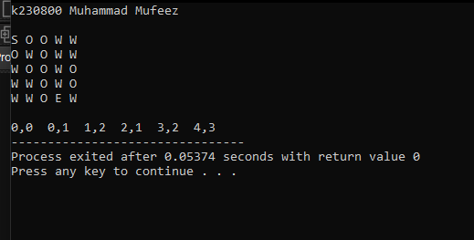

QUESTION 5

CODE

#include<stdio.h>

int main(){

printf("k230800 Muhammad Mufeez \n\n");

int i,j,k,l,n,num,l_side,r_side,temp,ret=0,arr[100],ind=0;

printf("Enter n: ");

scanf("%d",&n);

num= n*n*n;

temp =n*n*n;

for(i=1;i<n;i++){

for(j=i+1;j<n;j++){

for(k=i+1;k<n;k++){

for(l=i+1;l<n;l++){

l_side = i*i*i + j*j*j;

r_side= k*k*k + l*l*l;

if(l_side>num){

ret=1;

break;

}

else if(l_side == r_side && l_side!=temp){

temp = l_side;

arr[ind]=l_side;

ind++;

}

if(ret==1)

break;

}

if(ret==1)

break;

}

if(ret==1)

break;

}

if(ret==1)

break;

}

//sorting series in ascending order

for(i=0;i<ind-1;i++){

for(j=0;j<ind-1;j++){

if(arr[j]>arr[j+1]){

temp = arr[j+1];

arr[j+1]=arr[j];

arr[j]=temp;

}

}

}

//printing sorted series

for(i=0;i<ind;i++){

printf("%d, ",arr[i]);

}

printf("\b\b ");

return 0;

}

OUTPUT

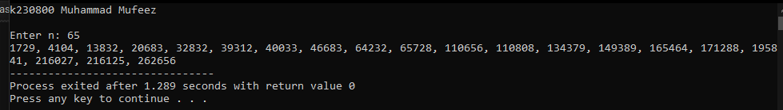

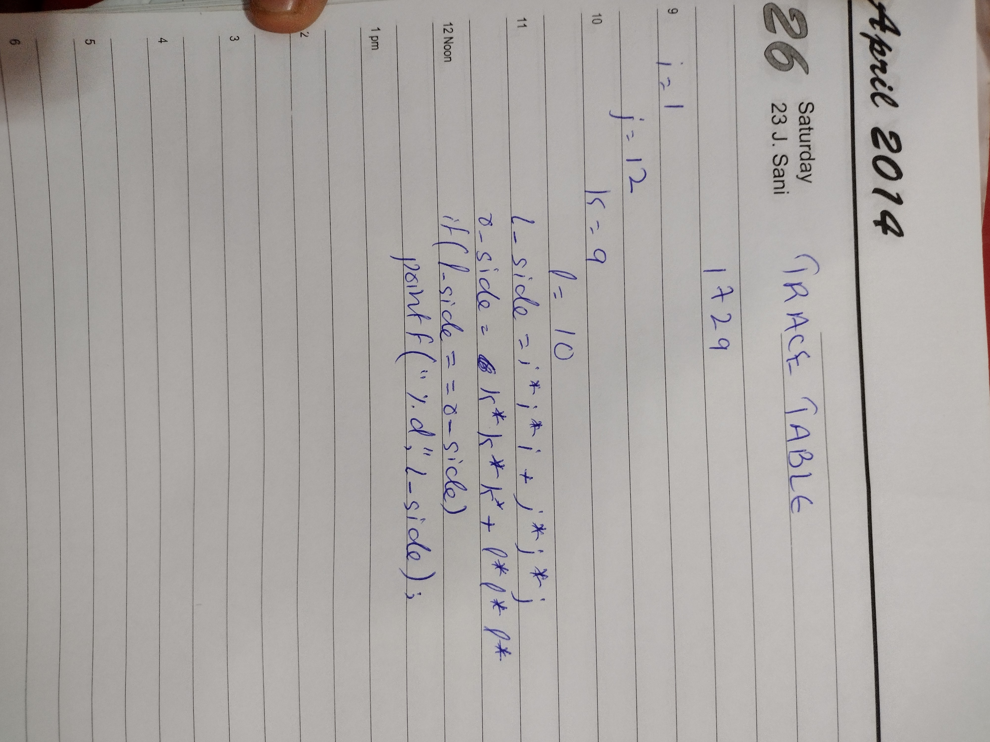

QUESTION 6

CODE

#include<stdio.h>

int main(){

printf("k230800 Muhammad Mufeez \n\n");

int i,j,t,n;

printf("Enter length of array: "); //input for length of array

scanf("%d",&n);

printf("Enter sum: "); //input for t

scanf("%d",&t);

int arr[n];

printf("\nEnter array: "); // to input the array

for(i=0;i<n;i++){

scanf("%d",&arr[i]);

}

// printing the pairs

printf("\nPairs: ");

for(i=0;i<n;i++){

for(j=i+1;j<n;j++){

if((arr[i] + arr[j])==t){

printf("(%d, %d)",arr[i],arr[j]);

printf(", ");

break;

}

}

}

printf("\b\b ");

return 0;

}

OUTPUT

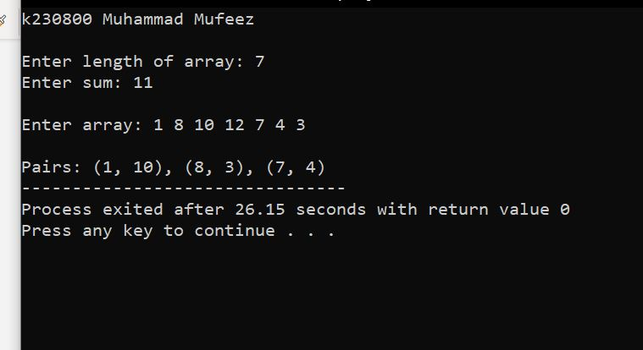

QUESTION 7

CODE

#include<stdio.h>

int main(){

printf("k230800 Muhammad Mufeez \n\n");

int i,j,shirts=0,temp=0,temp1=0,ret;

printf("Enter no of shirts: "); //input for number of shirts

scanf("%d",&shirts);

int arr[shirts][2];

printf("\nEnter age and price of each shirt by putting an space in between: "); // input for array

for(i=0;i<shirts;i++){

printf("\nFor Shirt %d: ",(i+1));

for(j=0;j<2;j++)

scanf("%d",&arr[i][j]);

}

// sorting in ascending order wrt age

for(i=0;i<shirts;i++){

ret=0;

for(j=0;j<shirts-1;j++){

if(arr[j][0]>arr[j+1][0]){

temp = arr[j][0];

temp1= arr[j][1];

arr[j][0]=arr[j+1][0];

arr[j][1]=arr[j+1][1];

arr[j+1][0]=temp;

arr[j+1][1]=temp1;

ret=1;

}

}

if(ret==1)

i--;

}

// printing array in ascending order wrt age

printf("\n\nSorted list in ascending order with repect to age: \n");

for(i=0;i<shirts;i++){

for(j=0;j<2;j++)

printf(" %d",arr[i][j]);

printf("\n");

}

// sordting in descending order with respect to price

for(i=0;i<shirts;i++){

ret=0;

for(j=0;j<shirts-1;j++){

if(arr[j][1]<arr[j+1][1]){

temp = arr[j][1];

temp1= arr[j][0];

arr[j][1]=arr[j+1][1];

arr[j][0]=arr[j+1][0];

arr[j+1][1]=temp;

arr[j+1][0]=temp1;

ret=1;

}

}

if(ret==1)

i--;

}

// printing array in descending order wrt price

printf("\n\nSorted list in descending order with repect to price: \n");

for(i=0;i<shirts;i++){

for(j=0;j<2;j++)

printf(" %d",arr[i][j]);

printf("\n");

}

return 0;

}

OUTPUT

